**Circuit Diagram:**

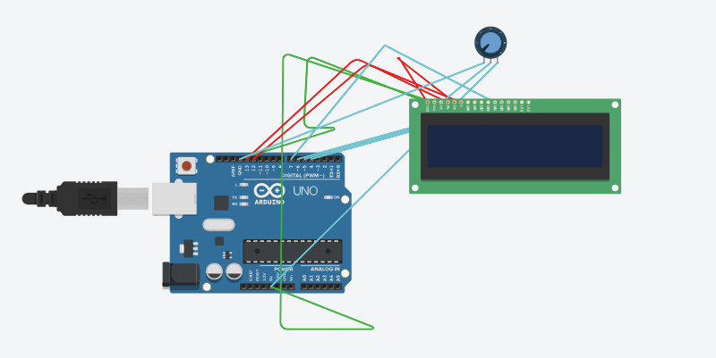

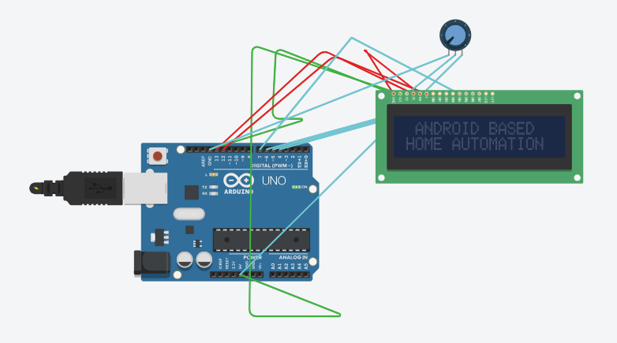

**Code:**

#include <LiquidCrystal.h>

#define L1 2

#define L2 3

#define L3 8

#define L4 9

#define L5 10

#define L6 11

const int en = 13, rs = 12 , d4= 7, d5 = 6,d6 = 5, d7 = 4;

LiquidCrystal lcd ( en,rs,d4,d5,d6,d7);

void setup() {

Serial.begin(9600);

pinMode(L1,OUTPUT);

pinMode(L2,OUTPUT);

pinMode(L3,OUTPUT);

pinMode(L4,OUTPUT);

pinMode(L5,OUTPUT);

pinMode(L6,OUTPUT);

lcd.begin(16,2);

lcd .clear();

lcd.setCursor(0,0);

lcd.print("GOVT. POLY. DEEH");

lcd.setCursor(0,1);

lcd.print(" SADAR UNNAO ");

delay(3000);

lcd .clear();

delay(300);

lcd.setCursor(0,0);

lcd.print(" GUIDED BY ---");

lcd.setCursor(0,1);

lcd.print(" DHIRENDRA SIR ");

delay(3000);

lcd .clear();

delay(300);

lcd.setCursor(0,0);

lcd.print(" GUIDED BY -

void loop() {

if(Serial.available ()>0){

lcd .clear();

lcd.setCursor(0,0);

lcd.print(" 1|2|3|4|5|6|GRP");

lcd.setCursor(0,1);

lcd.print(" | | | | | | 12.");

char r = Serial.read();

if(r =='A')

digitalWrite(L1, HIGH)

lcd.setCursor(1,1);

lcd.print(r);

}

else if(r =='B')

digitalWrite(L2, HIGH);

lcd.setCursor(3,1);

lcd.print(r);

}

else if(r =='C'){

char c = r;

digitalWrite(L3, HIGH);

else if(r =='a'){

char a = r;

digitalWrite(L1, LOW);

lcd.setCursor(1,1);

lcd.print(a);

}

else if(r =='b'){

char b = r;

digitalWrite(L2, LOW);

lcd.setCursor(3,1);

lcd.print(b);

}

else if(r =='c'){

char c = r;

digitalWrite(L3, LOW);

lcd.setCursor(5,1);

lcd.print(c);

}